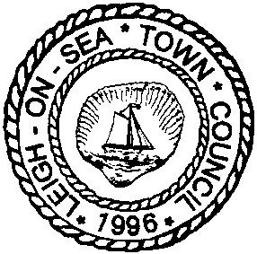
Leigh-on-Sea Town Council

71-73 Elm Road, Leigh-on-Sea, Essex SS9 1SP - Tel: 01702 716288
council@leighonseatowncouncil.gov.uk www.leighonseatowncouncil.gov.uk
Vice-Chairman: Cllr Valerie Morgan
Town Clerk: Helen Symmons

NOTICE TO ALL RESIDENTS WITHIN THE TOWN COUNCIL BOUNDARY

The 22nd Annual Town Meeting
will be held at Leigh Community Centre at the above address
on Friday 20th April 2018 at 7.00 p.m.

Prior to the meeting, from 6.00pm, there will be the opportunity to talk informally to Councillors and view community exhibits. Light refreshments will be available in the café. Following the meeting there will be a bar and a chance for informal conversation and further viewing of exhibits.

AGENDA

- OPENING OF MEETING

Welcome and introduction of Councillors.

- APOLOGIES

- MINUTES OF 21TH ANNUAL TOWN MEETING HELD ON FRIDAY 28TH APRIL 2017

To note and accept the minutes of the Annual Town Meeting 28th April 2017 (Appendix 1)

- REPORT OF THE VICE-CHAIRMAN

Vice-Chairman, Cllr Valerie Morgan will provide a brief report on the previous year along with a special presentation.

- PRESENTATION OF LOCAL COUNCIL AWARD

A presentation to Leigh-on-Sea Town Council by the Chairman of Essex Association of Local Councils and Chairman of the Essex County Accreditation Panel, Cllr Peter Davey

- COMMUNITY GUEST SPEAKERS

Short presentations from the Litter Less Leigh group and the Two Tree Island Group

- GOOD FOR LEIGH AWARDS

Presentation of Awards

- ANNUAL REPORT OF THE TOWN COUNCIL

To receive the Annual Report for 2017/18 (this will be available prior to the meeting) and to answer any questions on the Council and Committee’s activities over the year.

- OBSERVATIONS

- RESOLUTIONS

To consider resolutions of which written notice has been given by Thursday 12th April 2018.

- OPEN FORUM

During a limited time, to receive questions or comment from electors within the Town Council’s boundary relating to matters of interest specific to Leigh. Answers to questions may be given by a member or staff of the Town Council, or the invited representatives of the Borough Council. If we are unable to respond to any question at the meeting, we will follow the matter up with the resident in person.

Cllr Valerie Morgan
Vice-Chairman
5th April 2018

Exhibition stands to date include:

- Leigh-on-Sea Town Council Events
- Leigh Farmers Market
- Essex Police Special Constables
- Royal British Legion – Leigh Branch
- Leigh Society
- Two Tree Island Group
- Leigh Lions
- Leigh Art Trail

